* **THE GIT HUB LINK WITH THE 3 HTML AND 3 CSS:**

<https://github.com/Esperanza647/old-ivy--final-proyect>

**LOOK FOR INSPIRATION :**

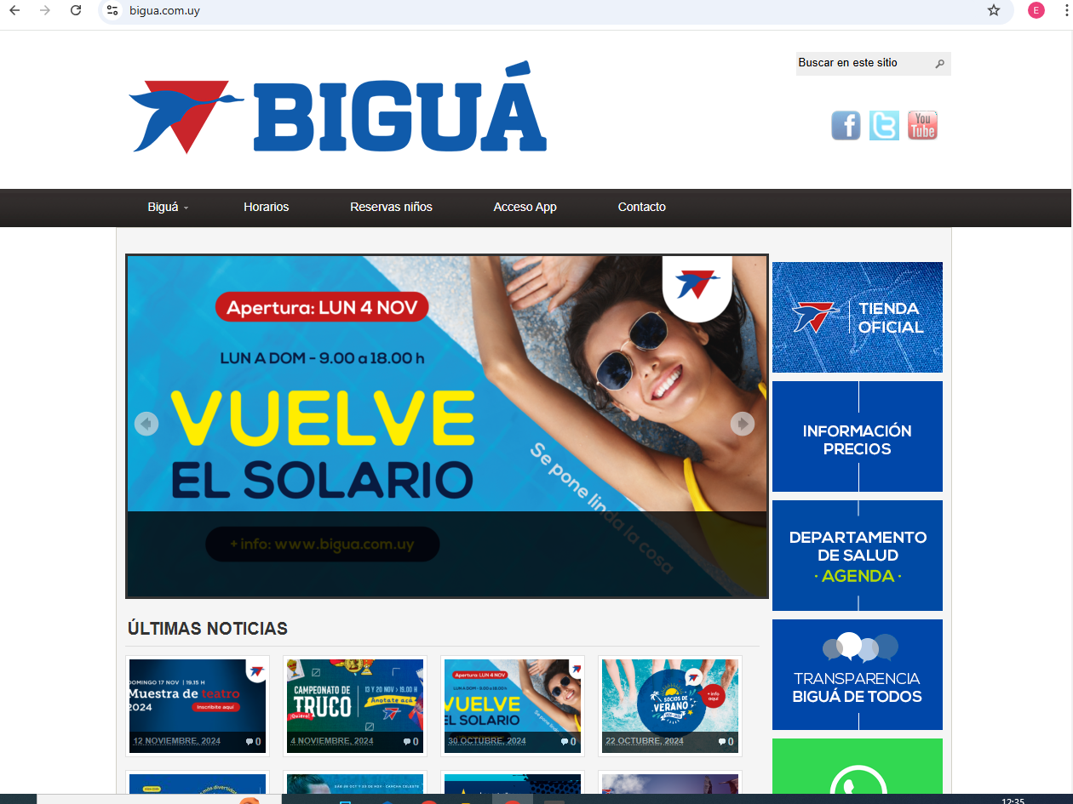

bigua.com.uy

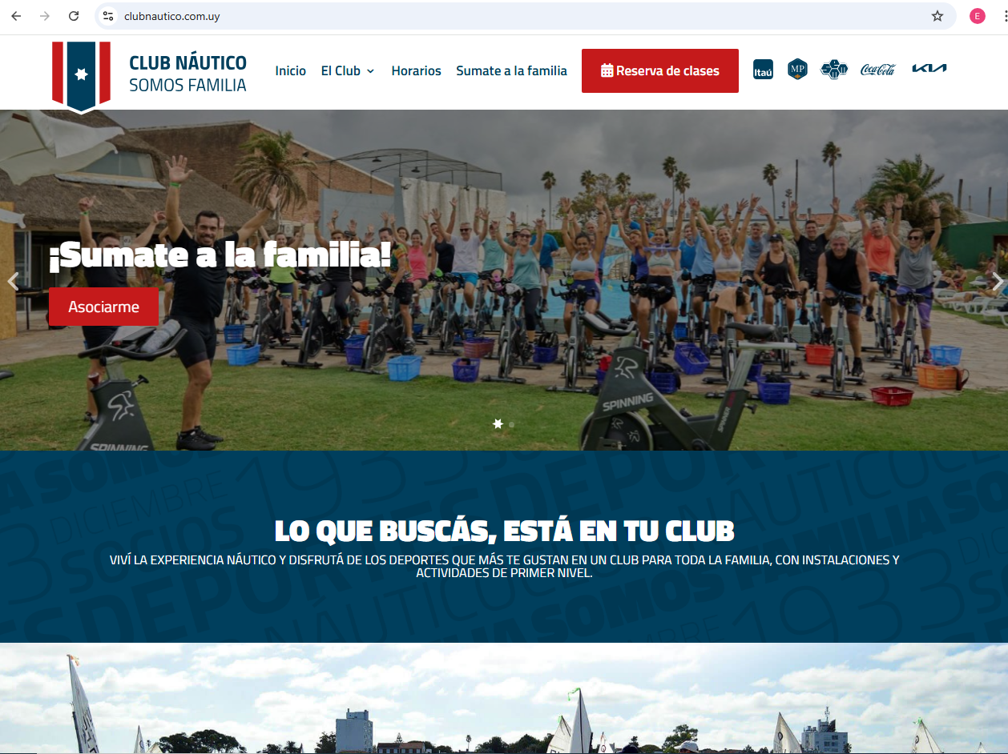

clubnautico.com.uy

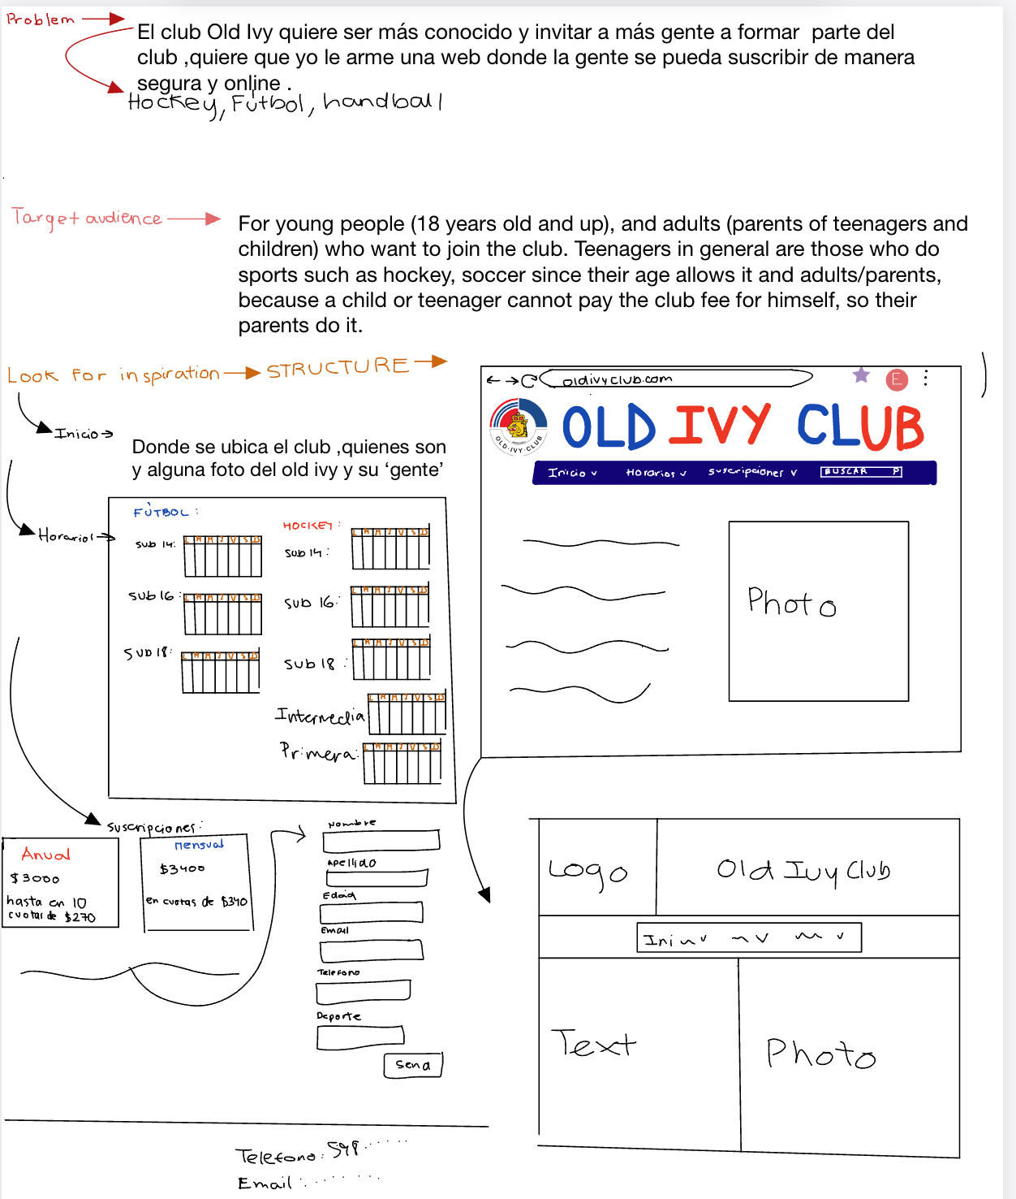

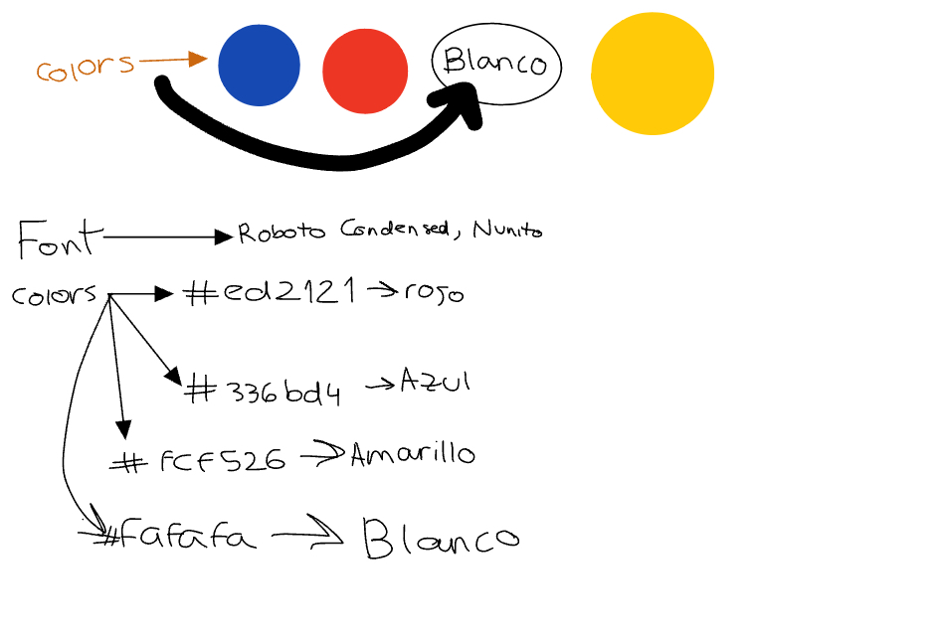

* **Solution Concept**: This website will bind you a place where the audience can subscribe safely and quickly online (a new website that the Old Ivy Club will have)
* **Font:** Roboto Condensed; Nunito
* **Colors:** -#ed2121; -#336bd4; -fcf526; - #fafafa;-#0a0a0a

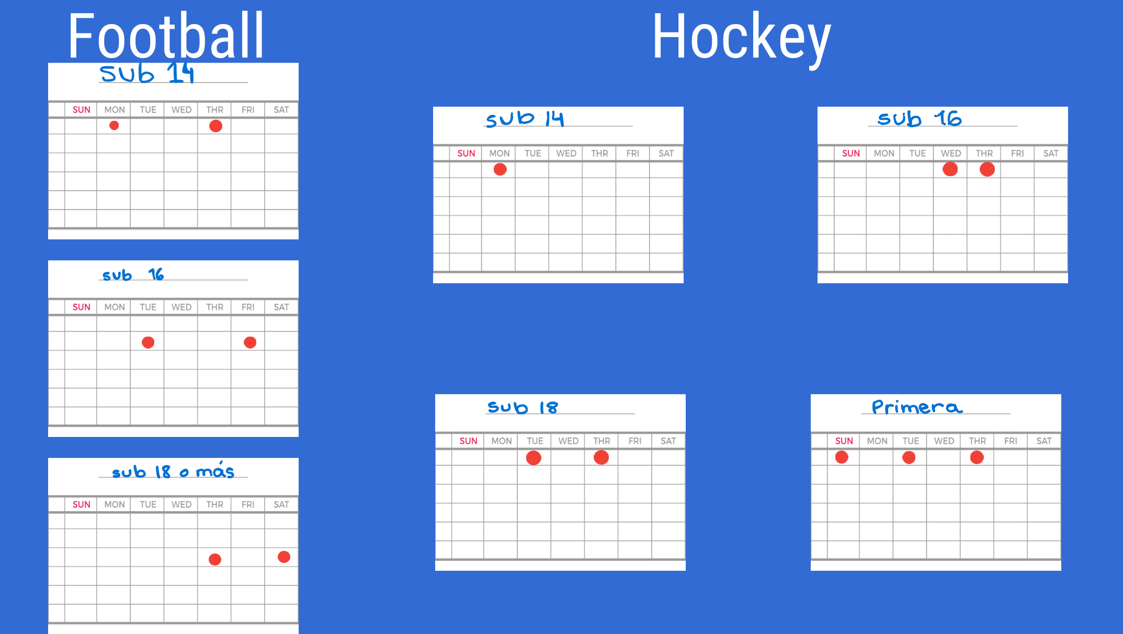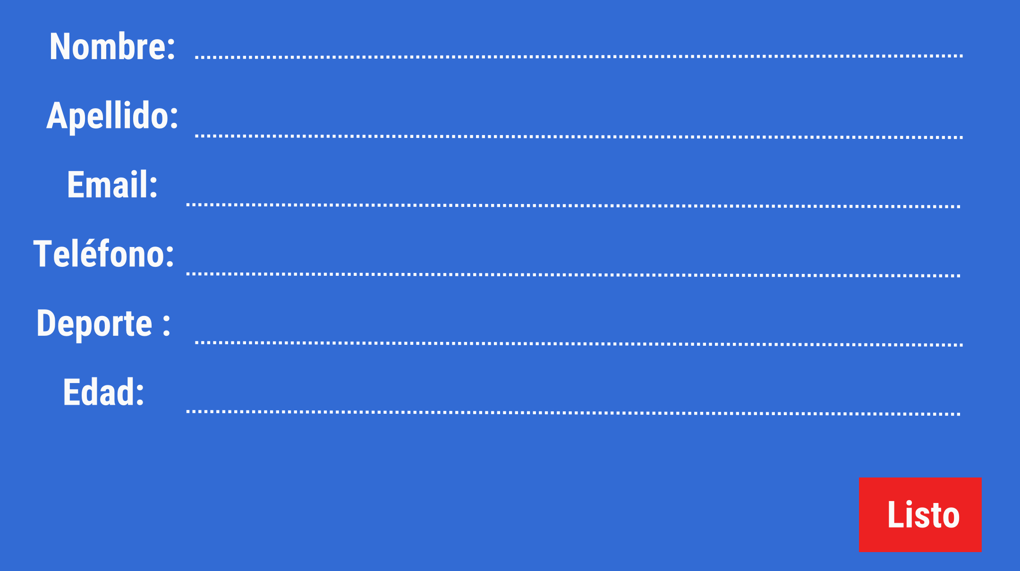

**final result :**

